|  |  |  |  |  |
| --- | --- | --- | --- | --- |
| **S.No.** | **Type of Event** | **From Date** | **To Date** | **Brief Description** |
| **1** | **BATTLE OF BANDS @ VJIT** | **1ST MARCH,2024** | **1ST MARCH,2024** | **Vidya Jyothi Institute of Technology have organized the event of Battle of Bands on 1st March,2024 as a part of their main fest, UDHBHAV’24.** |
| **2** | **BATTLE OF BANDS @ KG REDDY INSTITUTE OF TECH.** | **6TH MARCH,2024** | **6TH MARCH,2024** | **KG Reddy Institute of Technology have organized Battle of Bands competition on 6th March,2024 as a part of their annual fest, INVICTA’24.** |
| **3** | **BATTLE OF BANDS @ VNR VJIET** | **16TH MARCH,2024** | **16TH MARCH,202** | **VNR VJIET have organized Battle of Bands event on 16th March,2024 where several music bands from various colleges and institutes have participated.** |
| **4** | **FLASH GIG @MGIT** | **18TH MARCH,2024** | **18TH MARCH,2024** | **Flash Gig is the first event conducted by Symphony-Music Club of MGIT on 18th March,2024 as a part of annual fest, NIRVANA’24 where the club came up with many performances to showcase their talent. The event took place near the retreat of MGIT campus.** |
| **5** | **BATTLE OF BANDS @MGIT** | **22ND MARCH,2024** | **22ND MARCH,2024** | **Battle of Bands is an electrifying event conducted by Symphony-Music Club of MGIT as a part of the annual fest, NIRVANA’24 where several music bands across various colleges and institutions have participated.** |
| **6** | **VOICE HUNT @MGIT** | **23RD MARCH,2024** | **23RD MARCH,2024** | **Voice Hunt is an event conducted by Symphony-Music Club of MGIT as a part of the annual fest,NIRVANA’24 where many singers across colleges have participated to showcase their talent in various trends of Music.** |
| **7** | **MAIN STAGE PERFORMANCE – NIRVANA ‘24** | **23RD MARCH,2024** | **23RD MARCH,2024** | **The Main Stage Performance is the final event conducted by the Music Club of MGIT on 23rd March,2024 where the club came up with some electrifying performances to showcase our talent and passion towards the club.** |

**Name of the club: SYMPHONY (MUSIC CLUB OF MGIT)**

**PHOTOS**

**BATTLE OF BANDS @VJIT**

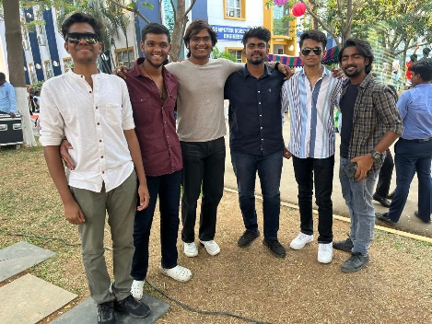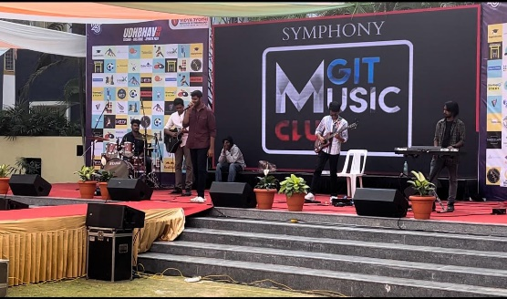

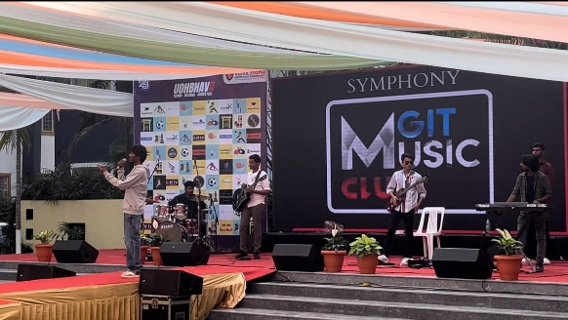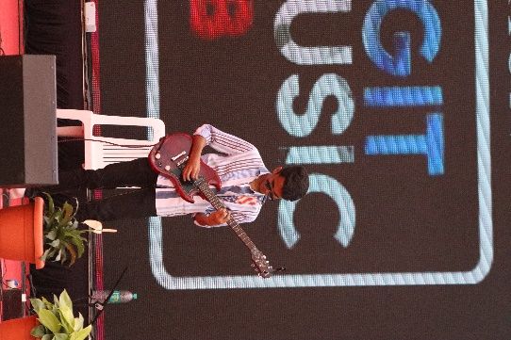

**BATTLE OF BANDS @KG REDDY INSTITUTE OF TECH.**

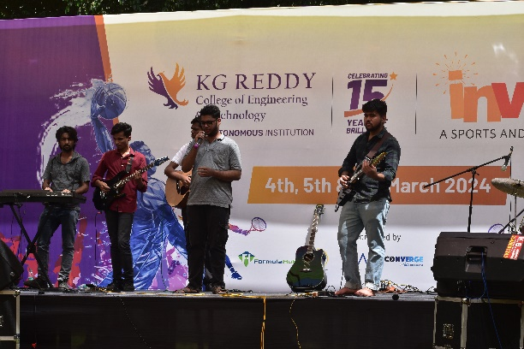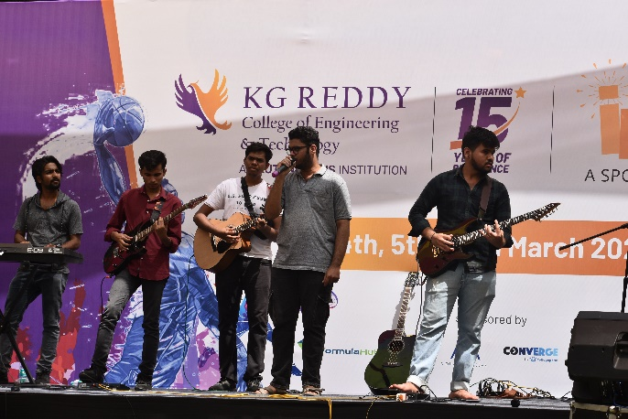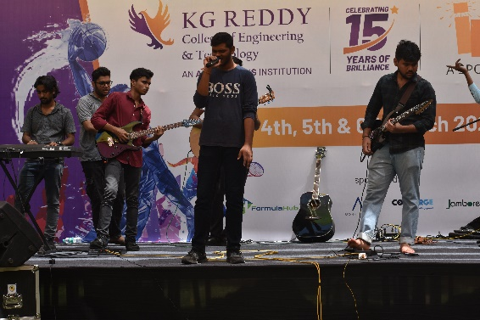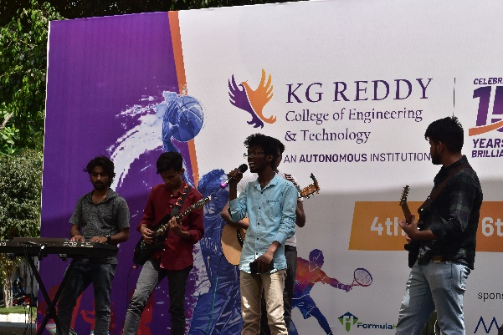

**BATTLE OF BANDS @VNR VJIET**

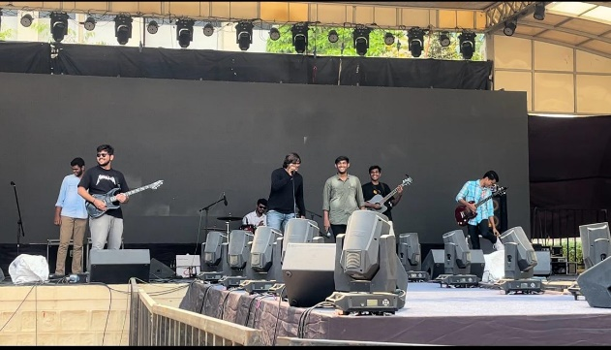

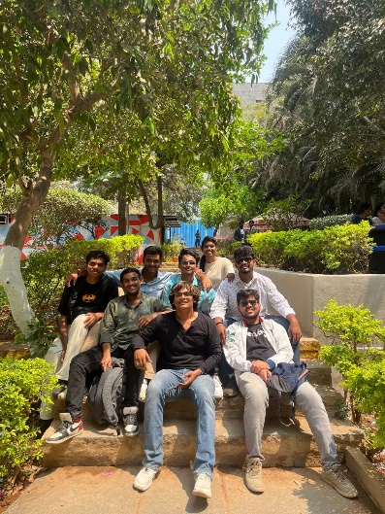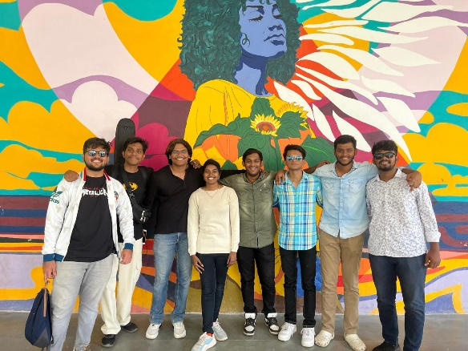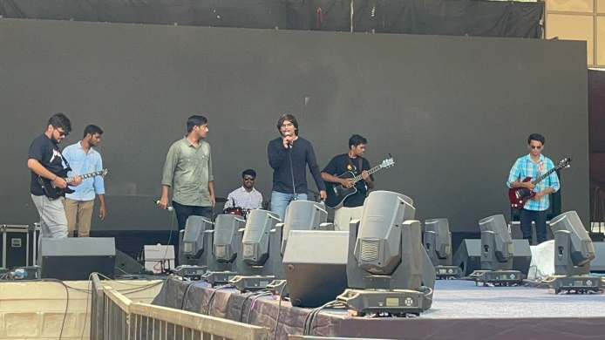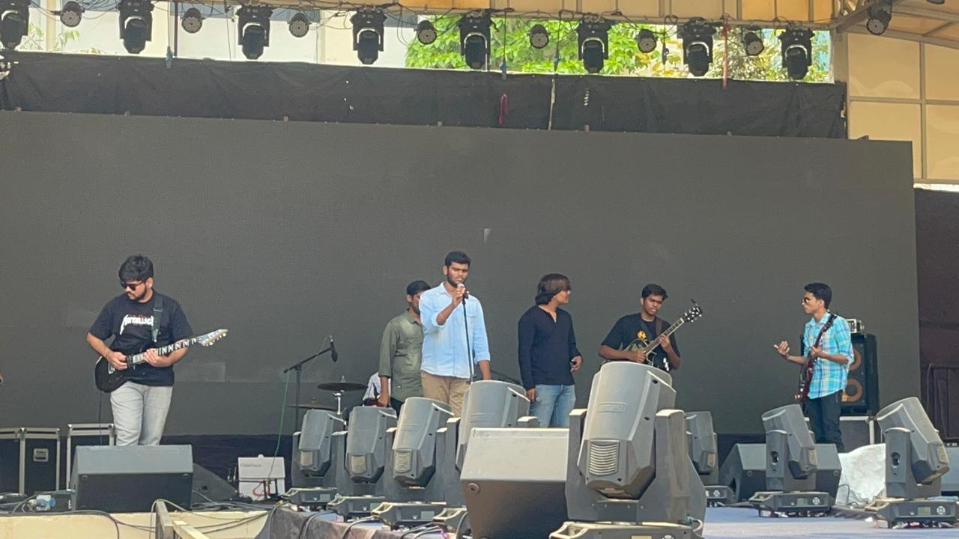

**FLASH GIG @MGIT**

 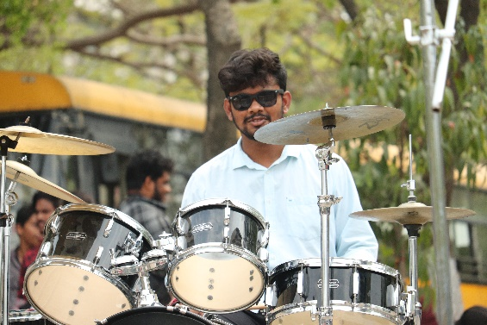 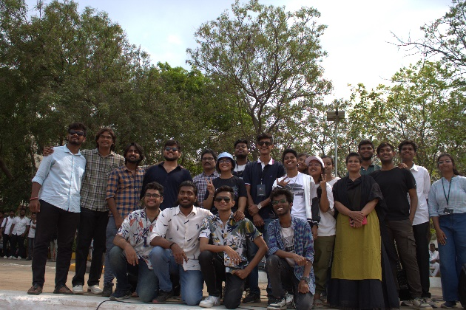 

**BATTLE OF BANDS @MGIT**

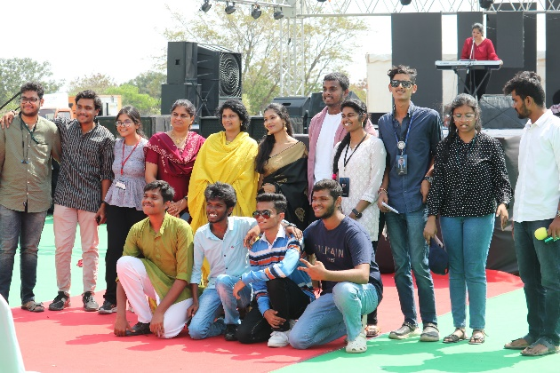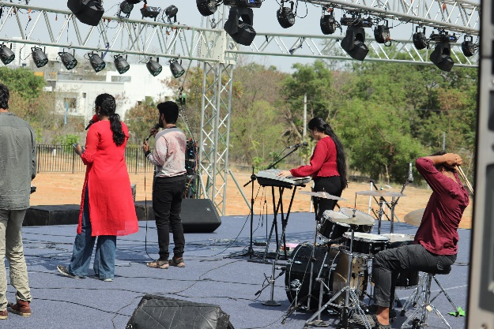

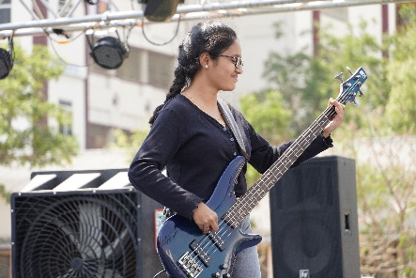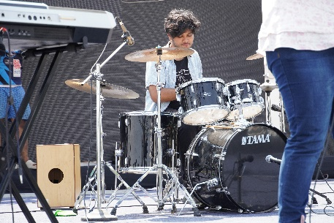

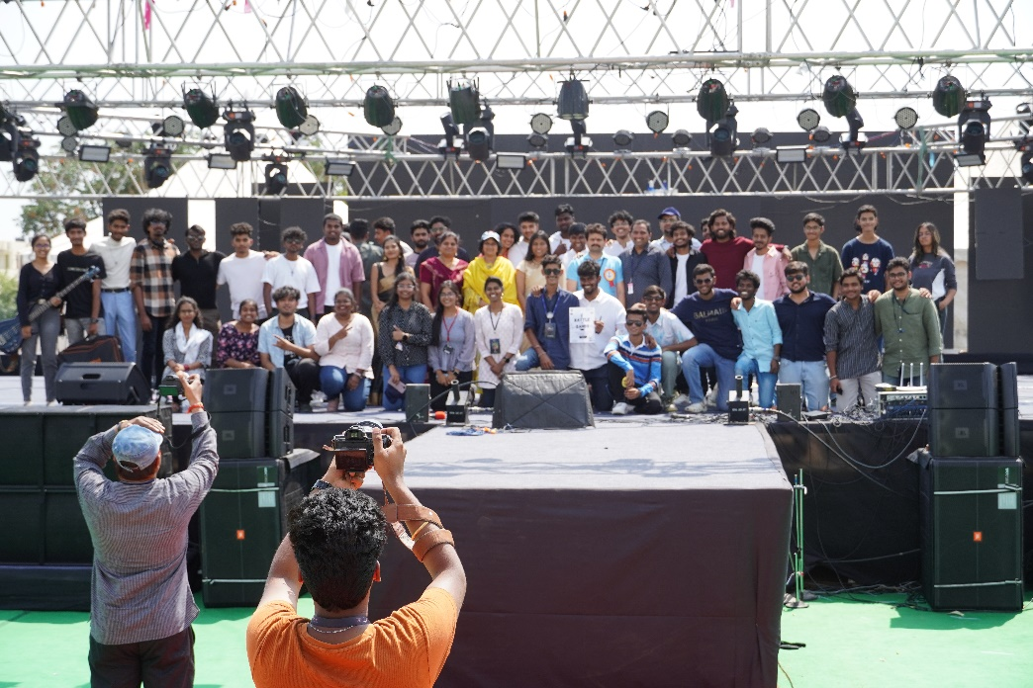

**VOICE HUNT @MGIT**

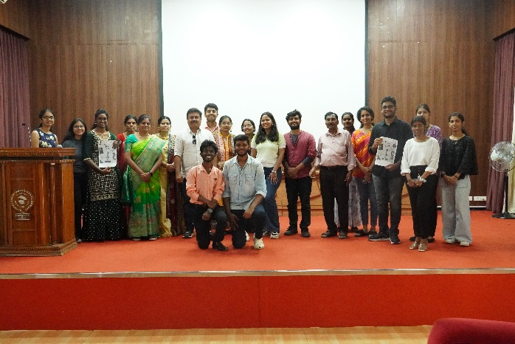 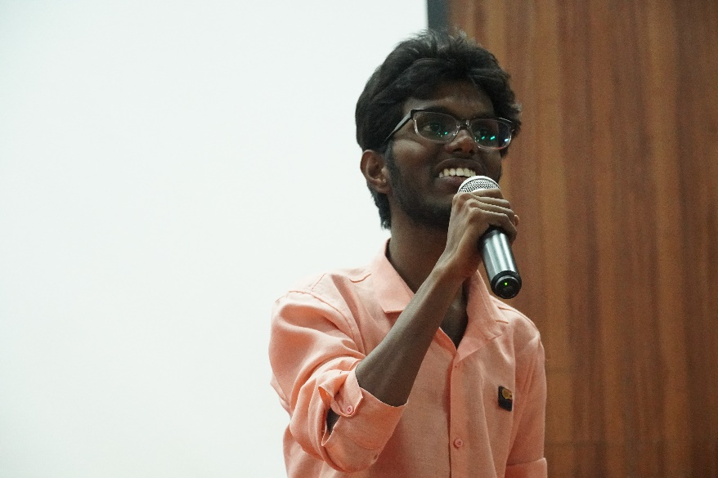

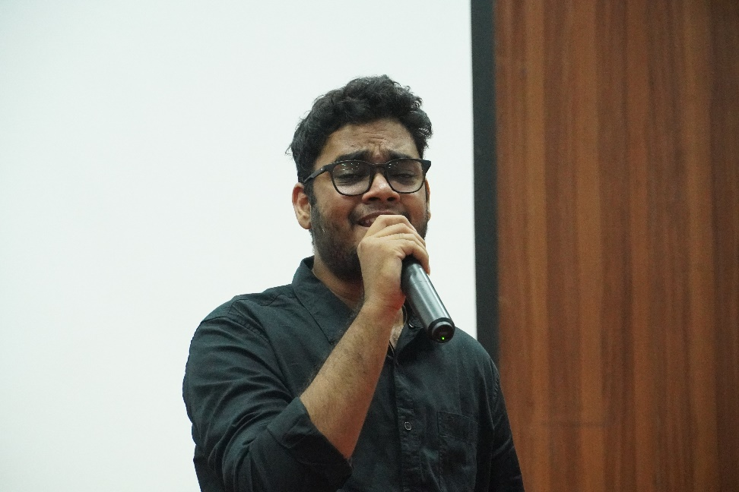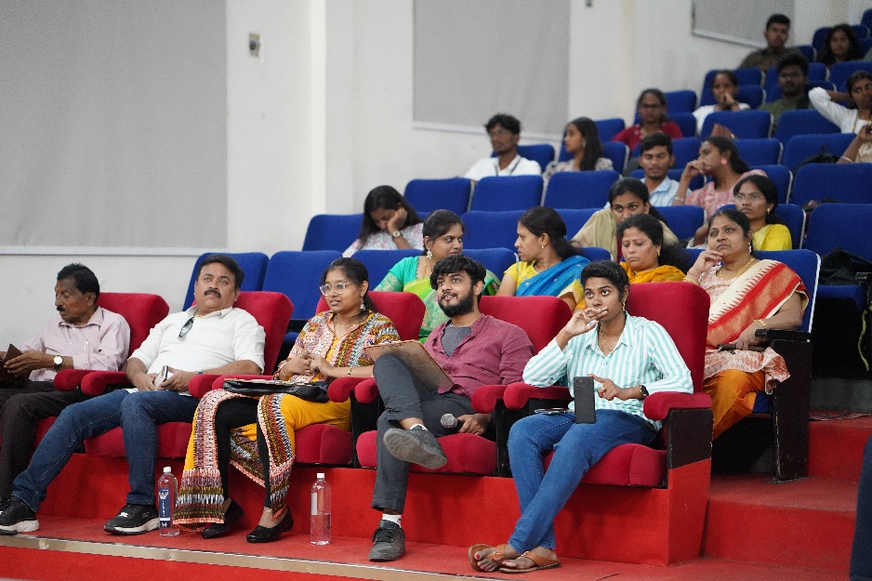 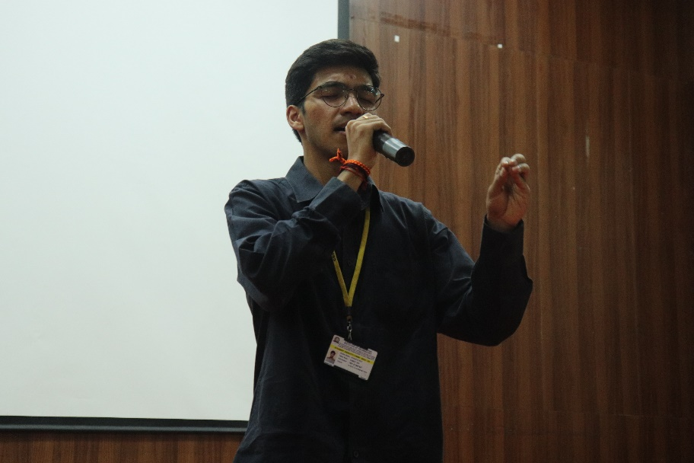

**MAIN STAGE PERFORMANCE -NIRVANA ‘24**

